End to End ML Projects
- Setup the GitHub (It is a repository for committing our code and collaborating with other teammates during the development. Also, helps in version control)
- Create a new GitHub Repository
- Create a local project folder
- Open command prompt and go to the local folder path using cd command
cd D:\mlproject
- Enter ‘code .’ to open the folder in VS code

- New Environment
- Open Terminal in VS code
- Type, conda create -p environment_name python==python_version
conda create -p venv python==3.8
- Activate your environment, conda activate environment_name/
conda activate venv/

- Clone the GitHub repository by following below commands:
- Initialize git repository
(D:\mlproject\venv) D:\mlproject>git init
Initialized empty Git repository in D:/mlproject/.git/
- Add readme file in the VS code project folder
(D:\mlproject\venv) D:\mlproject>git add Readme.md
- Commit the folder
(D:\mlproject\venv) D:\mlproject>git commit -m "First Commit"
[master (root-commit) aeffb01] First Commit
1 file changed, 1 insertion(+)
create mode 100644 Readme.md
- Checkout branch to main
(D:\mlproject\venv) D:\mlproject>git branch -M main
- Add origin
(D:\mlproject\venv) D:\mlproject>git remote add origin https://github.com/vishalsinghblr/mlproject.git
- Push to the repository
(D:\mlproject\venv) D:\mlproject>git push origin main
Enumerating objects: 3, done.
Counting objects: 100% (3/3), done.
Writing objects: 100% (3/3), 256 bytes | 256.00 KiB/s, done.
Total 3 (delta 0), reused 0 (delta 0), pack-reused 0
To https://github.com/vishalsinghblr/mlproject.git
* [new branch] main -> main
- Create a .gitignore file in the repository and select gitignore template as ‘Python’ and commit changes. (It will ignore all the files that are not required to be committed to the repository)
- Pull from the repository to have the latest data
(D:\mlproject\venv) D:\mlproject>git pull https://github.com/vishalsinghblr/mlproject.git
From https://github.com/vishalsinghblr/mlproject
* branch HEAD -> FETCH_HEAD
Updating aeffb01..7800dd6
Fast-forward
.gitignore | 171 +++++++++++++++++++++++++++++++++++++++++++++++++++++++++++++
1 file changed, 171 insertions(+)
create mode 100644 .gitignore

- setup.py (Build an entire machine learning application as a package- It can be installed and deployed)
- Create a file in VS code ‘setup.py’
- Copy-paste below code in setup.py file
from setuptools import find_packages,setup
setup(
name='mlproject',
version='0.0.1',
author='vishal',
author_email='vishal.singh2114@gmail.com',
packaged=find_packages()
install_requires=['pandas','numpy','seaborn']
)
- ‘install_requires’ is not feasible as there could be ‘n’ number of libraries required.
Therefore, a function ‘get_requirements‘ is created and the code changes as follows:
from setuptools import find_packages,setup
from typing import List
HYPHEN_E_DOT='-e .'

def get_requirements(file_path:str)->List[str]:
'''
This function will return the list of requirements
'''
requirements=[]
with open(file_path) as f:
requirements=[req.replace('\n','') for req in f.readlines()]

if HYPHEN_E_DOT in requirements:
requirements.remove(HYPHEN_E_DOT)

setup(
name='mlproject',
version='0.0.1',
author='vishal',
author_email='vishal.singh2114@gmail.com',
packaged=find_packages(),
install_requires=get_requirements('requirements.txt')
)

- To execute ‘find_packages()’ (all folders with __init__.py will be considered as a package, it will build as a package, and it can be imported anywhere)
- Create a folder named ‘src’
- Create a file named ‘__init__.py’
- requirements.txt (packages that needs to be Installed while Implementing a project)
- Create a file in VS code ‘requirements.txt’
- Add all the required libraries
- Add ‘- e.’ at the end in ‘requirement.txt’ file to automatically trigger and run setup.py file
- As, ‘-e.’ is included in the requirements.txt file it should be excluded from the code in setup.py file.
- To download the requirements, in terminal type
pip install -r requirements.txt
- Source folder ‘src’ is created and the package is built as shown below:
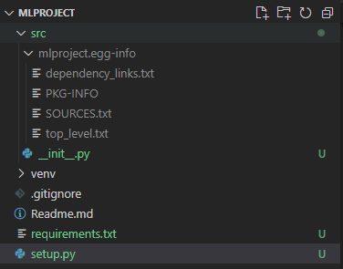
- Create a folder as ‘components’ in ‘src’ folder and create ‘__init__.py’ file
- components are the modules that are going to be created for e.g. data_ingestion - reading data from a specific database
- Similarly, create for other modules as shown below:
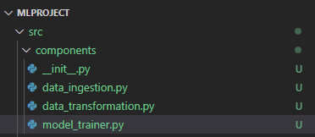
- Create a folder as ‘pipeline’ in ‘src’ folder and create ‘__init__.py’ file
- Modules for training and prediction to be created as ‘train_pipeline’ and ‘predict_pipeline’
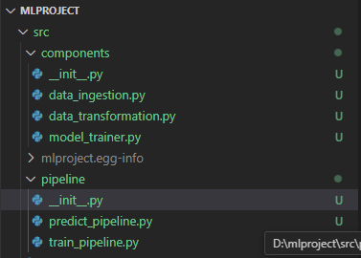
- Create other files as ‘exception.py’, ‘logger.py’ and ‘utils.py’ files in src folder as shown below:
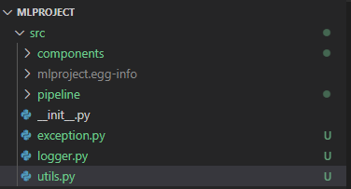
- ‘exception.py’ (generic) module to implement exception handling, which allows a program to gracefully respond to errors or unexpected situations during execution
import sys

def error_msg_detail(error, error_detail:sys):
_,_,exc_tb=error_detail.exc_info()
file_name=exc_tb.tb_frame.f_code.co_filename
error_message="Error occured in python script name [{0}] line number [{1}] error message [{2}]".format(
file_name,exc_tb.tb_lineno,str(error))
return error_message

class CustomException(Exception):
def __init__(self,error_message,error_detail:sys):
super.__init__(error_message)
self.error_message=error_msg_detail(error_message,error_detail=error_detail)

def __str__(self):
return self.error_message

- ‘logger.py’ (generic) module to record errors, unusual circumstances, and other information about an application's state
import logging
import os
from datetime import datetime

LOG_FILE=f"{datetime.now().strftime('%m_%d_%Y_%H_%M_%S')}.log"
logs_path=os.path.join(os.getcwd(),"logs",LOG_FILE)
os.makedirs(logs_path,exist_ok=True)

LOG_FILE_PATH=os.path.join(logs_path,LOG_FILE)

logging.basicConfig(
filename=LOG_FILE_PATH,
format="[%(asctime)s] %(lineno)d %(name)s - %(levelname)s - %(message)s",
level=logging.INFO,
)
- ‘utils.py’ to store a collection of reusable utility functions and helper classes that can be accessed from various parts of the application
- Create a folder as notebook, download and place the data. Start with EDA steps in jupyter notebook.
- To install ipykernel for VS code:
conda install -c conda-forge ipykernel
- After working on EDA and Model Training to finally select the model, move to ‘data_ingestion.py’ to prepare handle the continuous flow of live data from any data source (data engineers)
- Data ingestion code
- To run python files, it may give module not found error. It can be run using following command:
python -m src.components.data_ingestion
where, data_ingestion is the .py file, components is the folder and src is the parent folder
- Add ‘.artifacts’ in .gitignore file that is created from data_ingestion module
- Data Transformation code
- Model Training code
- Final changed – Take final code
- Create an app.py file in ML project folder
- Create a ‘templates’ folder and add all html files required according to Flask app devloped in app.py

